Ideation Phase
Define the Problem Statements

Date | 11 October 2025
Team ID | SWUID20250177148
Project Name | SB Works
Maximum Marks | 2 Marks

Customer Problem Statement Template:
Purpose: To define the core problems freelancers face while searching for jobs online, and use those insights to guide the development of SB Works.
General Customer Problem Statement
- I am: A freelancer actively looking for consistent and fairly paid work opportunities online.
- I'm trying to: Find reliable clients and projects without wasting time bidding endlessly or facing delayed payments.
- But: Existing platforms are oversaturated, charge high fees, and offer little support to new freelancers.
- Because: They prioritize client-side features, leaving freelancers with minimal tools to stand out or manage jobs efficiently.
- Which makes me feel: Undervalued, insecure about my income, and unsure whether I can rely on freelancing full-time.
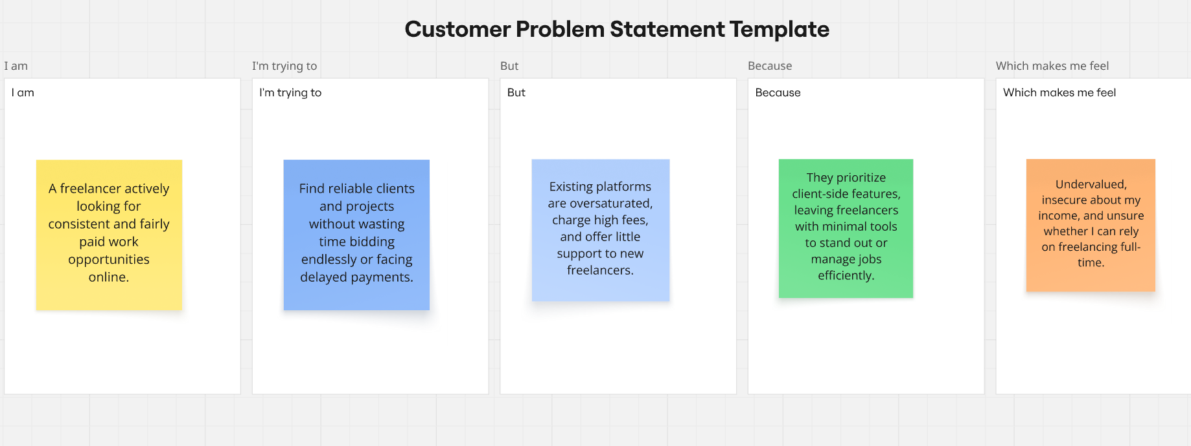

Problem Statement (PS) | I am (Customer) | I’m trying to | But | Because | Which makes me feel
PS-1 | a freelance web developer.. | land steady projects | competition mainstream platforms is overwhelming | many clients opt for the cheapest bid | frustrated and demotivated.
PS-2 | a freelance graphic designer. | showcase my portfolio to potential clients effectively, | platform limits personal branding tools |  | I can't stand out or grow my career.

